# Visiting the Land of a Million Waterfalls: New York

Greetings from Upstate New York! It feels like we've been on a second honeymoon this week, traveling around and seeing the sights. So much fun!!

We've been to Morgantown, WV, Kirtland, Ohio, Lake Erie, PA, Niagara Falls, NY, and Palmyra, NY so far. (Today is Thursday, June 24th) I can't wait to share our adventures with you!

**Update:

We are now safely home as of last night. (Today is Tues. 6/29)



Monday:

After cranking out my last blog post back in Harpers Ferry, WV, we finally headed out around lunchtime toward Morgantown. The reason we chose to go here is because A) it looked like a lot of fun with outdoor recreational opportunities, and B) we wanted to see if this might be a place we'd like to retire to someday.

As we headed out, I got a video call from Kylie in Italy. We chatted for a while as we drove along! Thankfully we had enough internet to do that . . . She's doing well, and the most exciting thing she shared is that Benson was able to feel their baby move for the first time! She'll be getting an important ultrasound very soon, and Benson got permission to accompany her! That's fantastic news. It will be so tempting for them to find out the gender, but they are going to try to refrain from cheating. I shouldn't even call it cheating, because it's their own baby . . . so they can do whatever they want! But they are wanting to wait until they are with all the family in Idaho later this summer to share the news then.

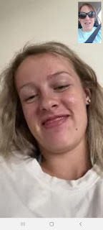

We stayed at the Hotel Morgan, an historic hotel built in 1925, and it still has some old, but fashionable features.

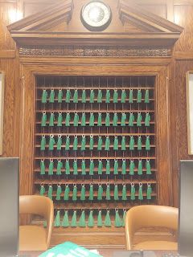

Fun fact: Don Knotts is from Morgantown! They even have a boulevard named after him.

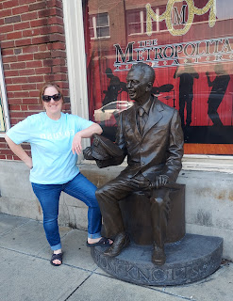

We walked around for a while before heading off to dinner. It was nice to get out of the car and in the fresh air. During our drive we had a substantial rainstorm that really knocked our socks off! Everyone on the freeway slowed down to 40 mph, our wipers were on high, and we could not see anything! Those raindrops were possibly the biggest, fattest raindrops we've ever seen.

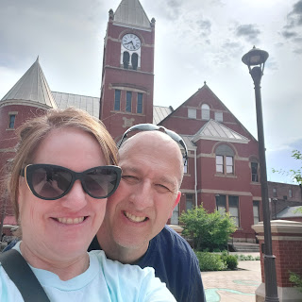

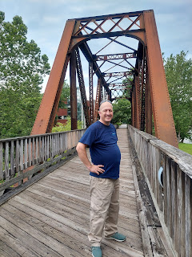

We chose to eat at Salam Restaurant, with Scott's favorite Middle Eastern fare. Salam = Peace.

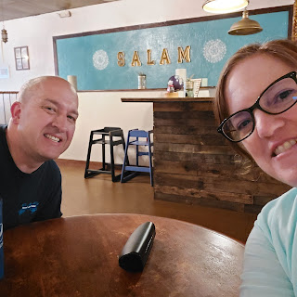

The falafel was AMAZING, and the lamb was so tender. Everything was so flavorful and delicious!

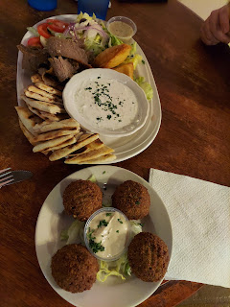

After sharing the combo platter, we shared the chicken shawarma as well. So good!

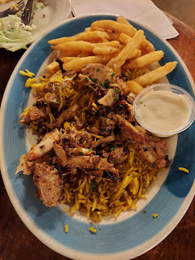

After we finished eating, we had to wait a little bit for the rain to slow down again before we could walk back down the street to our hotel. Thankfully, Hotel Morgan had an umbrella to loan us before we headed out.

Tuesday:

The rain lingered until mid-morning, so there was no hurry to get up and get dressed. Scott went on a short run while I exercised in our room. Soon, we were ready to start our day.

First, we drove a few minutes out of town over to Coopers Rock State Park. The drive itself was stunning.

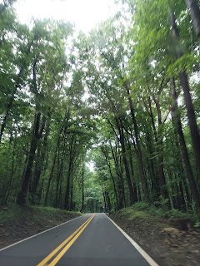

Click here to see a smidge of the lush forested drive: (16 seconds)

https://photos.app.goo.gl/J4mw2Czxmhwa25yK9

Due to the several hours' worth of rain, we chose to just drive all the way to the parking lot instead of walking along the trail to Coopers Rock. The distance was only a couple minutes away from our car to this beautiful view.

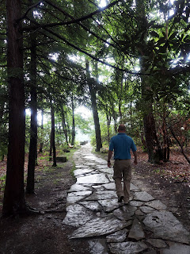

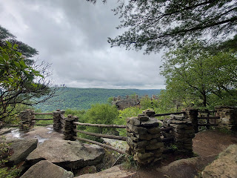

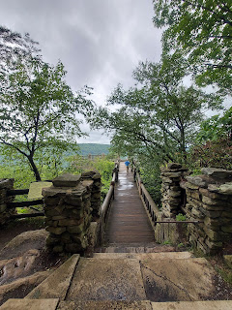

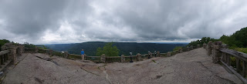

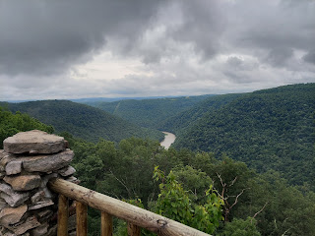

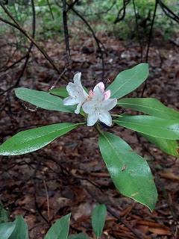

After a little bit of exploring, we decided to drive over to Cheat Lake next. We ordered some lunch at the restaurant down at Sunset Beach Marina, and then paid for a paddleboard for an hour of fun for yours truly. :) I LOVE paddle-boarding SO MUCH!!

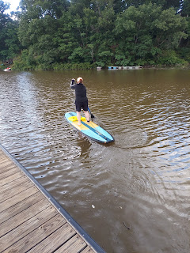

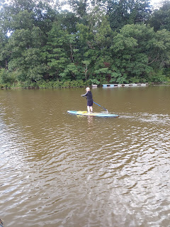

I forgot to bring my waterproof phone pouch that I wear around my neck on a lanyard. This allows me to have a safe place to keep my cell phone when I'm out on the water. So I opted to just leave it behind with Scott, since he didn't want to paddle board with me.

He took a short video of me coming back in. (12 seconds)

https://photos.app.goo.gl/YjMfQ2VTMwLpHQ1m8

The houses along the lake were spectacular. I wanted Scott to see the beautiful shoreline with me, so

once I got back with the paddle board, I talked him into renting a kayak for us to go back out together.

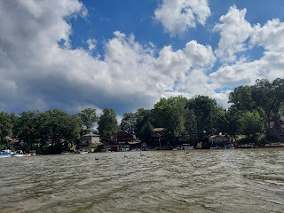

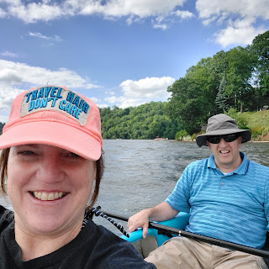

We paddled out from the harbor and then headed out to the bridge that spans across a portion of Cheat Lake.

Short video of us making our way out of the harbor: (26 seconds)

https://photos.app.goo.gl/EBNqPMhhnRgSaeis7

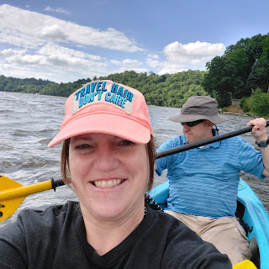

This home right here is a perfect example of the upper crust who live on the lake. I really loved the symmetrical staircases descending down into their back yard. Very impressive!

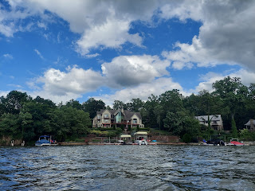

Way off in the distance, you can see the bridge we had as our goal. We wanted to go all the way out to it, then loop around underneath and head back.

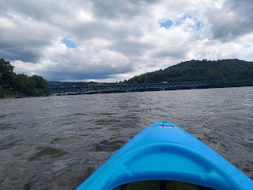

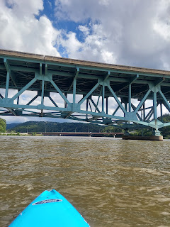

Short video of us getting there: (16 seconds)

https://photos.app.goo.gl/fBYz89aDTMAmtN1e9

We did it! We made our way back to the dock and then made our way back to the hotel for the evening.

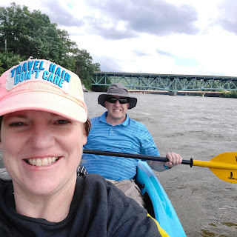

What a good workout though! First I paddled myself all along the shoreline on the paddle board, then Scott and I went a little bit further in the kayak to the bridge and back. That felt good.

We ordered some takeout for dinner and brought it back to our hotel room. We watched the movie "Cruella" and then went to bed. The movie was fantastic by the way.

Wednesday:

We drove back into the O-hi-O and quickly navigated to Kirtland, which is up near Cleveland.

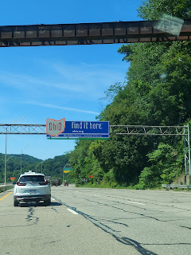

This whole middle section of our country is the heartbeat of America - where the bulk of our food is grown. Corn, wheat, etc. And it sure is beautiful!

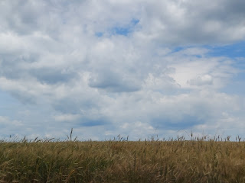

We arranged for a tour of the John Johnson Home in Hiram, Ohio on our way toward Kirtland, because it worked out perfectly to do that instead of having to drive all the way back out from town.

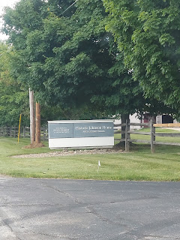

The Johnson family was very affluent back in the day and their home certainly reflected that in its furnishings.

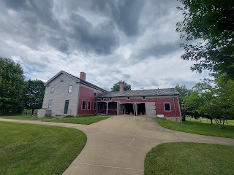

Something interesting back in those days was how they chose to incorporate artistry into the woodwork. Here you can see a hand-painted swirl pattern around the fireplace and even on the doors to the right.

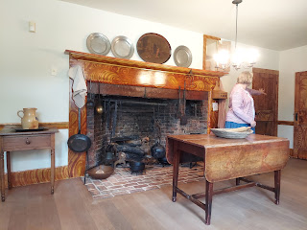

Elsa Johnson loved color in her home, and after a team of experts stripped the current paint on the wood trim and doors, they found original colors like teal, orange, and yellow for the accents. The experts then restored the colors to their original glory.

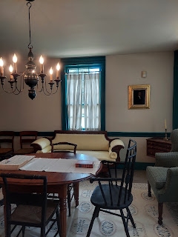

This was John Johnson. He was instrumental in helping Joseph Smith the Prophet to have a place to call home when persecution was rampant.

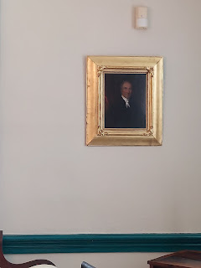

It was while Joseph and his little family were living here that a mob of tormentors showed up late at night and yanked him out of bed by his hair, dragging him outside for a severe beating. They didn't like that he had seen an angel, and that he had translated golden plates of ancient scripture. After beating him, they smeared warm tar all over him, even shoving some in his mouth, and then covered him in feathers before leaving him out in a nearby field and vanishing into the wee hours of the morning.

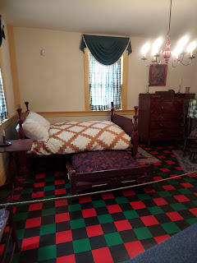

Joseph stumbled back to the house, where his wife Emma, along with Elsa Johnson and others, helped to carefully remove the feathers and scrub the tar off his skin as best as they could. Joseph had already planned to preach a sermon the following morning, and he stuck to that plan in spite of his injuries. It must have been quite a sermon because 3 people wanted to be baptized after he finished! And he recognized a few of the perpetrators in the audience as well. I wonder what they thought of him then! (or if they felt any ounce of remorse)

John and Elsa were innovative in some of their home's features. This built-in glass cabinet was not as common in those days.

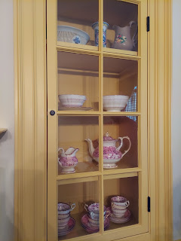

And this cupboard above the fireplace was where they would store blankets and even pajamas to keep warm over the fire! A warmer! How clever.

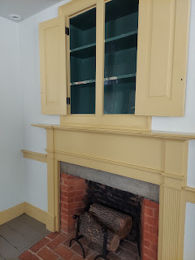

Elsa did a lot of sewing and even made her own threads. Our tour guide shared that if someone in the family outgrew an article of clothing, such as a shirt, or if it got torn, they didn't just throw it away or take it to Goodwill.

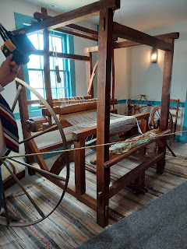

Elsa would have asked the family member to cut up their shirt into long strips, as shown below in the foreground. Within about 4 days, she would take the fabric strips and make them into a fine woven rug, one of which is shown behind the strips. Not bad. An old shirt or two was converted into a nice bedroom or bathroom rug in a few days. What exquisite re-purposing.

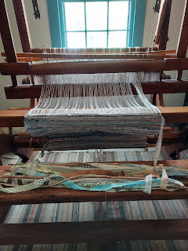

Below: Scott and me standing at the entrance to the Johnson home, with the original steps leading to the front door. The house was built in 1828.

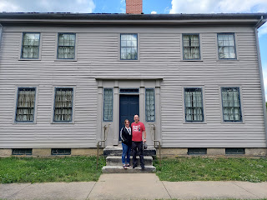

The farm behind the house.

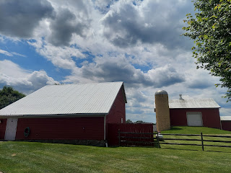

Next, after checking into our hotel in Mentor, Ohio, we drove just a few miles to Kirtland for our historic tour.

I absolutely loved this painting in the Visitor's Center.

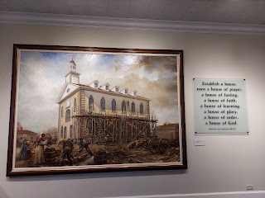

We toured the Newel K. Whitney Store, where Newel's thriving business helped to fund some important needs for the early church. Joseph Smith and his family also lived upstairs at one point.

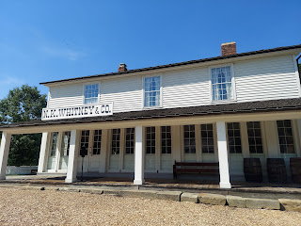

I loved this cute game of checkers as you enter the Whitney Store.

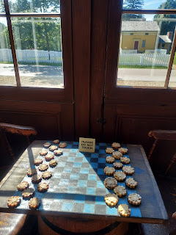

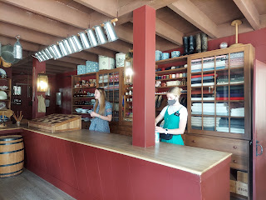

The living quarters upstairs, where Joseph and Emma lived for a time.

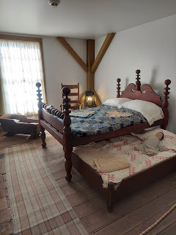

Original floorboards.

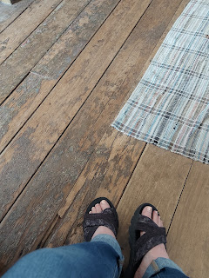

I particularly loved this room: the School of the Prophets, in a room upstairs from the store. This is where several men learned gospel principles and doctrines from the Prophet himself. It is also where Jesus Christ appeared to them one day during instruction. I tried to imagine where He would have stood, since the room would have been so full of students at the time. I really felt the spirit here in this sacred space, and I felt a sense of peace and wonder.

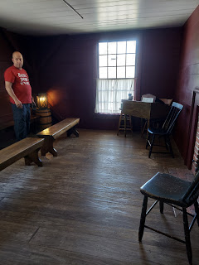

It was also a room that, once the students left for the day, needed a strong cleaning. Emma and other women would come in and scrub the floors because the men had been spitting tobacco on the floor during their lessons, as well as smoking tobacco using pipes. As she complained to her husband, he gave it some serious consideration and even prayed to get advice on the matter. God instructed him through a revelation known as the Word of Wisdom, encouraging church members to abstain from alcohol, tobacco, strong drinks such as coffee and tea, and to eat healthy foods and take care of their bodies. It wasn't uncommon in those days to wash and get dressed in fine Sunday clothes to come to the School of the Prophets, and then to smoke and spit tobacco juice on the floor. It was just what people did back then. I should add that after they received the admonition to stop using tobacco, the men threw their pipes and other tobacco supplies into the fireplace to signify their willingness to be obedient. Very admirable.

I really enjoyed this tour because so many of the buildings in Historic Kirtland were all close together, like a little mini-village. It was easy to walk from building to building as we went along.

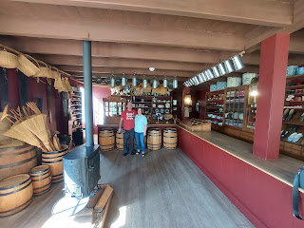

I also loved seeing the sawmill. For some reason an old sawmill always speaks to my soul.

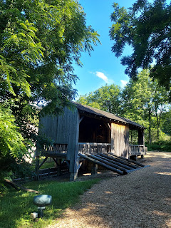

This shows how they would "squish" a giant tree length on either end, then slice it into planks for building homes and barns. The water wheel just outside would provide the power for the slicing.

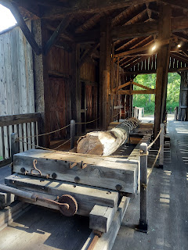

Next, we walked up the hill to see the Kirtland Temple, a magnificent sight.

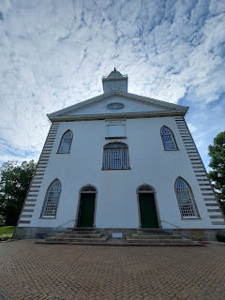

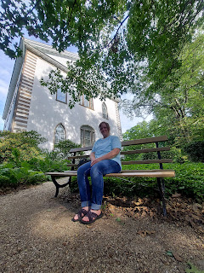

If you look closely, you might be able to see me in this next photo.

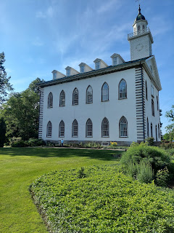

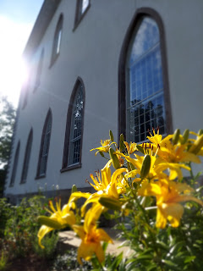

Meanwhile, Jack was getting his latest manicure in Washington D.C. :)

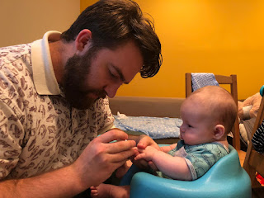

Thursday:

We finally made it into New York!!

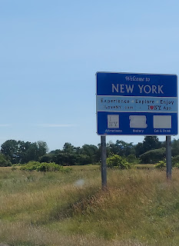

We stopped briefly at a small dock on Lake Erie. We had been driving alongside it for several miles, and what a beautiful lake it was, with its teal-blue water!!

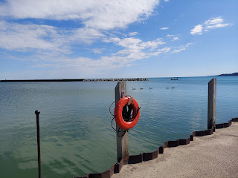

Next stop: Niagara Falls. The tall buildings across the bridge belong to Canada. We didn't go across.



But we did don a sporty blue poncho to get on the Maid of the Mist Tour boat.

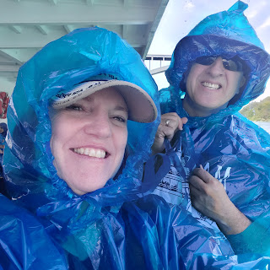

Channeling my own re-creation of a Titanic scene here . . .

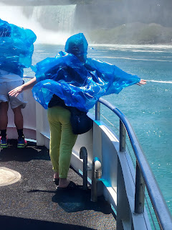

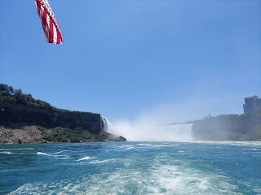

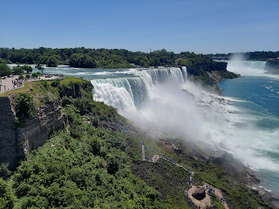

A couple of videos from our experience:

Video #1: (24 seconds) Soon after launching out from the dock.

https://photos.app.goo.gl/jsBmmhr1ezuvfWMx9

Video #2: (10 seconds) Really close to the falls - could hardly video anything because of the water, ha ha.

https://photos.app.goo.gl/1PfYjaY7jgxeKGgt6

Video #3: (32 seconds) Coming back to the dock, but zooming in on the crazy staircase we went up next. And it's RIGHT next to the falls!!

https://photos.app.goo.gl/bDTTR2duMN6M7W7L7

This is the only photo I got of us going up the stairs, I think. It was just TOO WET!

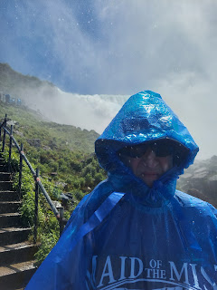

We walked over to the Luna Island lookout area next, which is the viewing area in between the two major waterfalls.

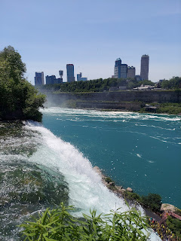

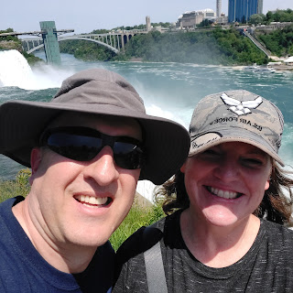

If you look closely, you can see people below wearing yellow ponchos. They are doing the Cave Tour, instead of the boat tour.

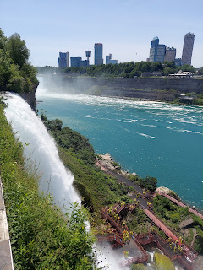

Video #4: This one I think is the most hilarious video of all!! Watch the crazy people who take turns standing on the landing to get pummeled. LOL (52 seconds)

https://photos.app.goo.gl/vvFdbAJG7e9RaNP46

After we finished up at Niagara Falls, we drove a little further to settle into Palmyra, NY for the night. We had a couple problems at our hotel upon arrival. The first room had a moldy smell in it, and soon after we came in, I noticed the floor was all wet in front of the mini-fridge. I let the lady at the front desk know, and she helped us change to another room. The second room was super humid and warm, and we couldn't get the AC to work. I went down to the front desk again, and after some effort that evening, we got the AC unit working and then things were fine for the rest of our stay. (2 days)

While the desk clerk tinkered with our AC, we went on a tour of the Grandin Print Shop on Main Street of Palmyra. This is where the Book of Mormon was first printed in 1830.

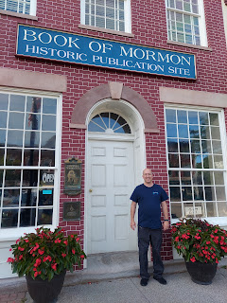

The Book of Mormon is a perfect companion to the Holy Bible.

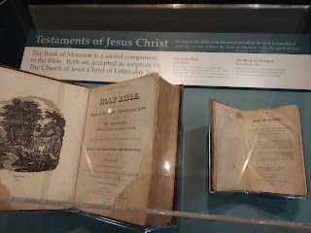

Two hemispheres. Two parts of the story. One Shepherd. One Christ. One Plan of Salvation for us all.

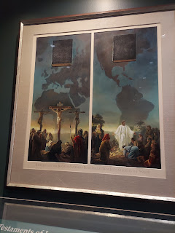

The sister missionaries giving the tour demonstrated how painstaking it all is to prepare each tiny letter into a composition stick, which is basically a paragraph. They showed us how all the sections are laid out, inked, and pressed onto paper.

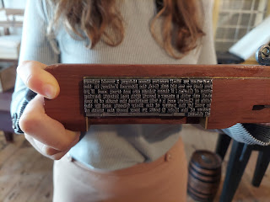

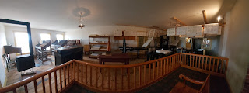

Upstairs, the pages are folded, pressed together, trimmed, and bound. If you really want to make a statement, you might add a leather cover to protect the book. Otherwise, it was just wrapped in paper.

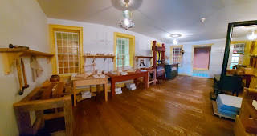

It took a lot of work and a long time to prepare 5,000 copies of the Book of Mormon, but with E.B. Grandin's new equipment, it "only" took 7 months to complete the job, instead of the otherwise projected 2 years.

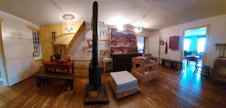

This intersection called Church Street (and Main Street) in Palmyra has 4 very old churches on each corner.

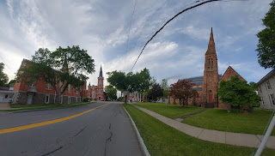

There is a Presbyterian Church, a Methodist Church, something, and an Episcopalian Church. I made a little video describing the scene here:

(1 minute, 46 seconds)

https://photos.app.goo.gl/aiwnqUA4mmnoyjp76

I got an answer to my question the following day, as to whether these 4 churches were all originally on that same spot in close proximity to each other. A senior missionary explained to me that most likely, no, that wasn't the case. Back in the olden days, they may have met at someone's house, or in a grove of trees. It most likely moved from location to location as the need arose.

But it was still a very cool corner with the 4 churches, all of which were nice and old. :)

Friday:

We walked over from our hotel to the Sacred Grove. (about 1/2 mile) This is a very sacred place because it was in this grove of trees that Joseph Smith, as a 14 year old boy, had a simple question - which resulted in an extraordinary answer. He merely wanted to know which church to join, as he was confused by all the different doctrines being preached so passionately at the time. He wanted to repent and know that he was "right" in the sight of God.

To know more, you are welcome to click here to get the full story of what happened.

https://history.churchofjesuschrist.org/content/the-first-vision?lang=eng

We walked into the grove together, slowly taking in the beautiful path through the trees, and eventually found a quiet place to reflect separately for a bit.

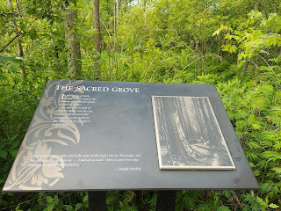

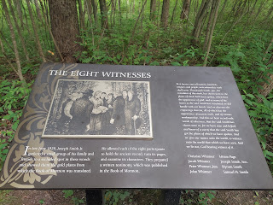

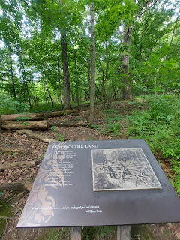

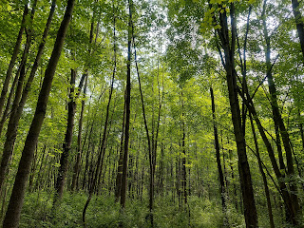

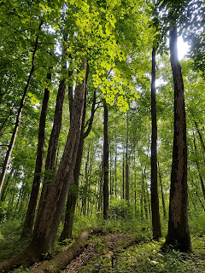

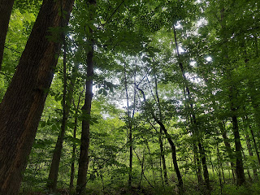

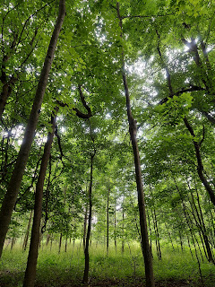

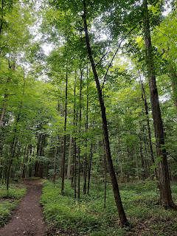

There are several trails to follow, all of which eventually lead back to the starting point. I found a quiet bench to sit on. I prayed, read some scriptures, and just enjoyed the absolute quietness of the grove. Other than the birds singing and talking to each other, there were no other sounds. That was a wonderful experience and I really felt the spirit in there.

You don't have to be in the Sacred Grove to have a spiritual experience or to feel the spirit of God. You can find your own "sacred grove", or quiet space, to commune with heaven. Shush the noise of the world, with all of its billboards, tv commercials, loud music, social media, and everything else that is a distraction from communicating with our Heavenly Parents. Take time each day to just be still.

After our quiet time in the grove, we went on a tour of the Smith family home and farm. It is not the original home, but is a very well built replica of how it would have looked in the early 1820's.

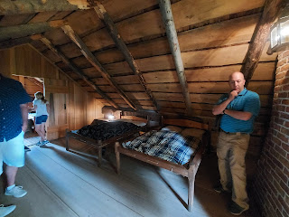

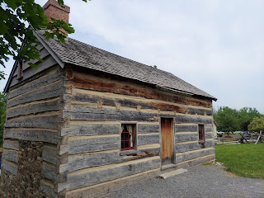

On the short trail between the log home and the frame house, you can see the Palmyra Temple across the fields. An interesting fun fact that the sister missionaries shared with us is that the windows in the front of the temple are clear (instead of frosted glass or stained glass). The reason is so that the view is unobstructed from one sacred place (the temple) over to another sacred place across the meadow (the sacred grove).

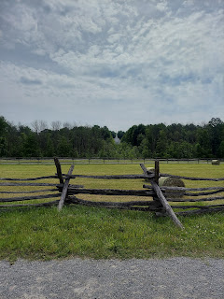

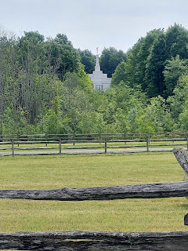

This is the frame house where the Smith family lived after they outgrew the log home.

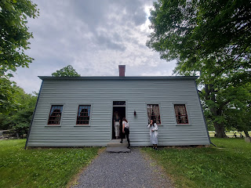

When Joseph retrieved the gold plates from the nearby Hill Cumorah, he had to be careful and vigilant in keeping the records safe from all those who were trying to steal them from him on a daily basis. One of the places he hid them was beneath these very same bricks in front of the fireplace. The hearth and the bricks below are original to the home. Other times he hid them in a barrel of beans, and even in between his two sisters who laid in bed and pretended to be asleep while the ransackers tore the rest of the house apart.

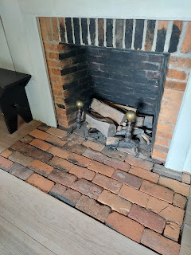

This is Emma Smith's kitchen sink, innovative for those days because it had a drain hole that exited the kitchen through a pipe to the outside. The beautiful farmhouse-styled cement sink would be very fashionable today as well.

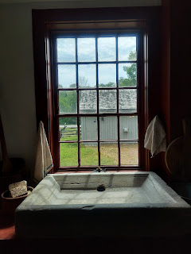

Opposite from the sink and window was the rest of the kitchen and dining area. To the right of Scott you can see a compartment within the fireplace. This was where Emma could bake bread and keep things warm. We were told that she could fit as many as a dozen loaves of bread in there at any given time.

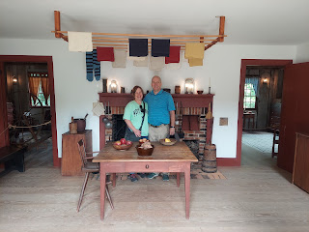

Outside, we were able to see a tree that Alvin Smith, Joseph's oldest brother, planted prior to his death in 1823. He was quite young when he died (25 yrs old), which came about accidentally. He had been given something to treat some "bilious colic", but it ended up causing mercury poisoning. What an awful way to die.

But the beautiful thing I wanted to share is that the tree he planted, a thornless honey locust tree, is quite majestic and enormous today, thriving very well during the past 200 years on the family property.

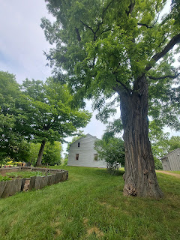

A longer glimpse of the Alvin Tree: (8 seconds)

https://photos.app.goo.gl/aX95tL1E7xZuoCy6A

Later that afternoon, after having a simple lunch and doing a load of laundry at our hotel, we drove 2  miles south to the Hill Cumorah. This beautiful representation of our Savior Jesus Christ was in the Visitor's Center.

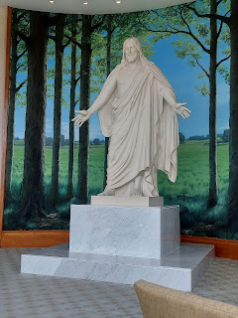

Also in the Visitor's Center was a beautiful stained glass panel, meant to represent when Moroni came to instruct Joseph Smith regarding the ancient records buried within the hill.

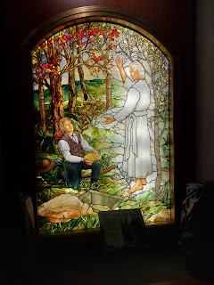

This is a replica of what the gold plates would have looked like, filled with centuries' worth of ancient history of the people on the North American continent. They would have also been quite heavy, considering what they were made of.

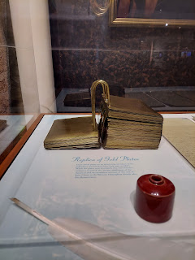

Today, we have the Book of Mormon in 110 languages, with many more translations currently in the works for other people throughout the world and their many dialects.

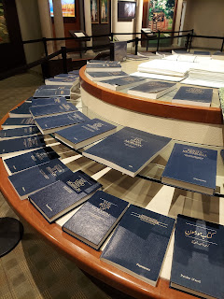

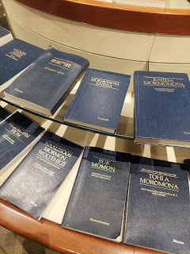

In the back of the Visitor's Center, there is a forested path leading up to the top of the Hill Cumorah. We almost didn't find it because right now there is a great deal of construction going on around there. I'm told that the plan is to try to smooth over all the unintentional scars from all the props and stage sets that were part of the Hill Cumorah Pageant since 1937. They have now ended the massive pageant forever, and the plan is to make the hillside look as if no one had ever tampered with it to begin with. :) At its peak, the pageant included close to 1,000 participants - with about 750 actors and 150 stage hands. Now, it is in the process of being returned to more of a quiet and reflective place for visitors to enjoy.

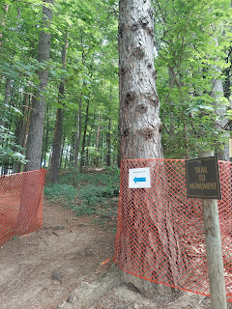

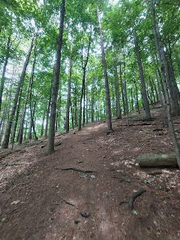

The trail leads up and up and up through a beautiful forest. I always love to pause and think about all those who have walked here over the centuries. It makes my heart swell almost to bursting! This is where I felt the spirit so strongly back in 2010 when I came with my daughter, Amber.

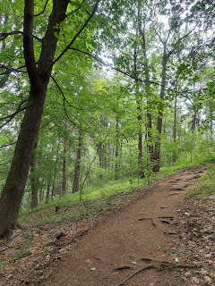

At the top, a beautiful monument has been erected to honor Moroni, an ancient prophet and scribe, who buried the golden plates here so long ago, and who helped Joseph Smith to find them approximately 200 years ago.

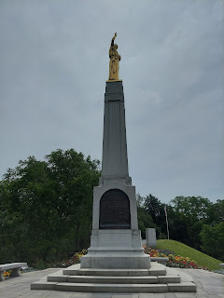

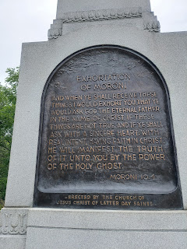

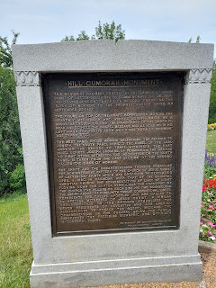

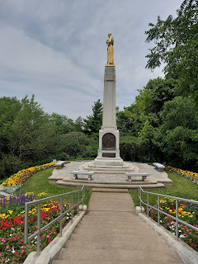

Here is a short video of the view from the top, overlooking the valley below. (19 seconds)

https://photos.app.goo.gl/bFTxJvedqfUb5hTu6

Next, we drove back into town where, just north of the 4 churches on the corner of Main Street, is the old farm that used to belong to Martin Harris. Martin worked closely with Joseph Smith, and was a major financial contributor to building up the restored church. At one point he mortgaged his own farm to come up with several thousand dollars of much-needed cash for the church.

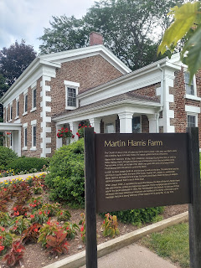

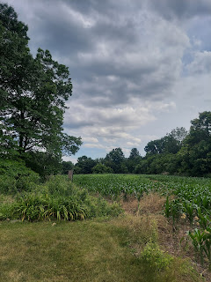

What is really unique about this house is the stonework on the exterior. The actual house that belonged to Martin Harris burned down in a fire, but they re-built it as close to its original state as possible.

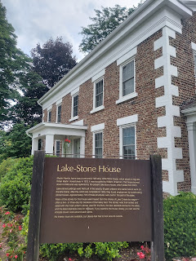

You can see the old chimney here, with evidence of the fire still lurking.

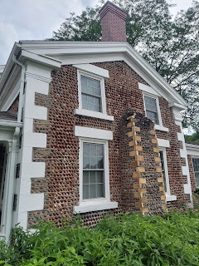

There are several other stone exterior homes in the area, and they are a sight to behold! One of the missionaries explained to us that back in the olden days, they would go to nearby Ontario to haul back several wagon loads of river rock. Then they would sort it into piles, according to size and similarity in appearance. They would use the most coordinating and uniform rocks on the front of the house, and then the mismatching ones would go on the sides of the house, with the worst miscellaneous ones purposed for the back of the house, ha ha.

Our last tour of the day was about 40 minutes away in Fayette Township, NY. This is where the Peter Whitmer Farm was located.

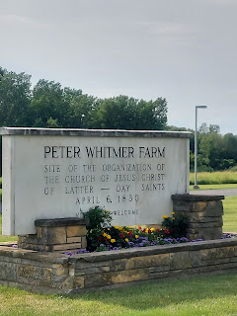

In the Visitor's Center, we learned a lot about what happened in the area there back in the 1820's and 1830's.

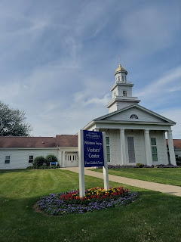

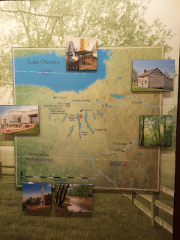

I loved this painting of Jesus.

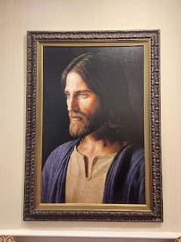

And this was an intriguing plaque underneath a bust of Jesus Christ. It says:

"This pedestal contains the Sesquicentennial Jubilee Box (1830 - 1980). Church of Jesus Christ of Latter-day Saints, Fayette, New York. Sealed April 6, 1980 by President Spencer W. Kimball. To be opened April 6, 2030."

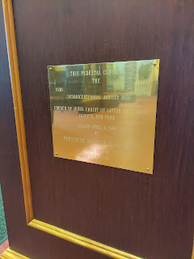

I wonder what's in there . . .

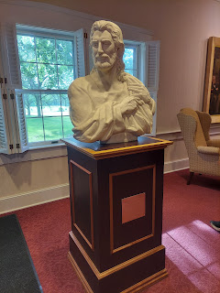

After watching a short movie, we went outside to visit the replica of the old Peter Whitmer family cabin.

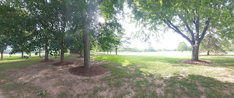

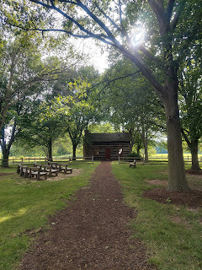

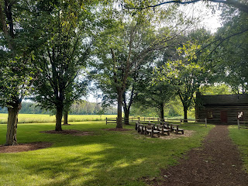

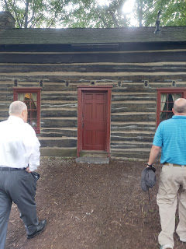

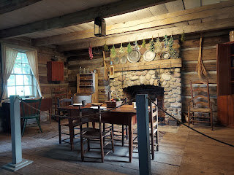

This is where the church was officially organized on April 6, 1830, and where a small group of participants gathered together.

It was an honor to stand in the same place, even if the house was technically a rebuilt house. I know what I felt in my heart, and that was good enough for me.

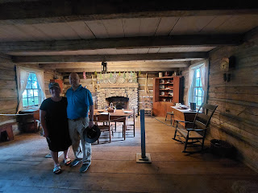

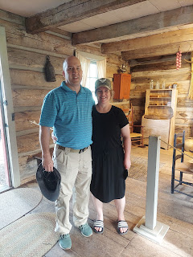

The movie that we watched (before touring the Whitmer cabin) was quite amazing and very moving. It's just 23 minutes long, and is available on YouTube.

Click here to watch it for yourself: It is called "A Day for the Eternities".

https://www.youtube.com/watch?v=KIqv3DI6PFg&ab_channel=LouisHerrey

I especially loved the miracle of the adjacent fields being plowed by an unknown source, angels perhaps, so that David Whitmer could be free to leave his father and all the work that needed to be done there so that he could go and help Joseph Smith instead.

This could have been the field where the miracle took place 200 years ago.

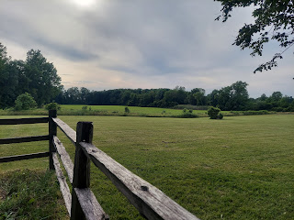

What a special, special place. I especially loved our tour being conducted by Elder Donaldson. You could tell he was very knowledgeable, and his passion for what went on here so long ago just spilled out of his heart and into his presentation.

He and his wife gave us a SOLID recommendation for dinner, and we were not disappointed! In the nearby town of Seneca Falls, NY, there is a market/deli/gift shop/café run by the local Mennonites.

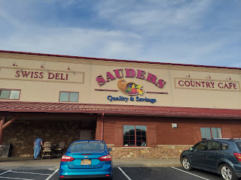

We ordered dinner first, since we were starving, ha ha. There weren't a lot of options on the menu, but we both ordered a wrap. Scott chose the spicier jalapeno cheese wrap, while I selected the spinach wrap. We could choose what went into our wraps, in a similar style to what you might do when ordering a sandwich at Subway. Only WAY BETTER.

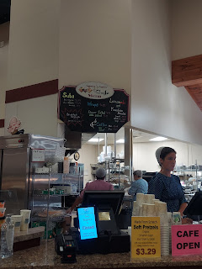

This was hands down the best deli-style wrap I have ever had. I don't know what made it so special, except that they do everything homemade here. No preservatives. It's all just so darn-tootin' fresh!! Even the pickles were amazing, and I'm not a huge pickle person.

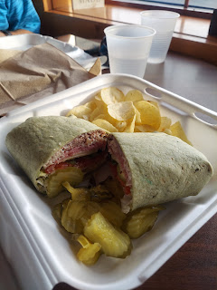

I only ate half of my wrap because I wanted to get some of their handmade ice cream. I ordered a SMALL. They told me it came with 2 scoops, so I chose toasted coconut (the lighter scoop on the bottom) and campfire s'mores. Oh. My. Gosh. The scoops were ginormous!! But I got all of this for a mere $3.00!! Amazing. And the ice cream was definitely the best ice cream I've ever had in my entire life!! And that includes all the delicious homemade ice cream we made as a family when I was growing up. (Sorry Mom and Dad)

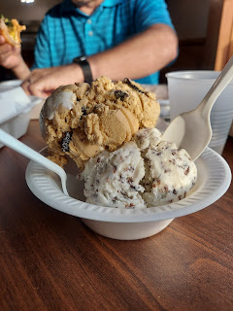

Others in the store told us that the meat selection here is the best meat in all of New York. So if you're ever out that way, and you need some fab cuts of meat for a BBQ, you might consider going to Sauder's in Seneca Falls.

They had several HAND-STITCHED quilts hanging throughout the store. I especially liked this one.

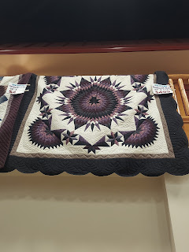

I had to hurry and make a few rushed purchases because the store was about to close. Overall, I was happy with what I got: a little hand-stitched coin purse, some handmade soaps, a book, some jams, a loaf of fresh honey wheat bread, and some locally grown apples.

By day's end, we received these epic photos in our family group chat on WhatsApp.

Jack-Jack. That precious little face.

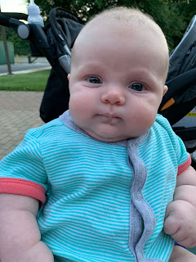

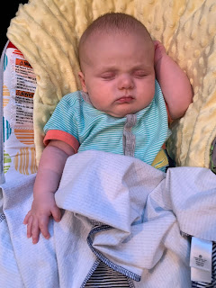

And Weston got his official diploma!

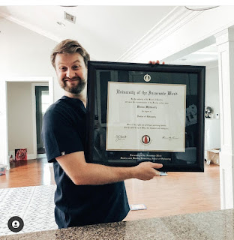

Saturday:

We got up early so we could catapult out of bed and get on the road. We had a long and very busy day planned!!

Driving south and along Lake Seneca, we saw some beautiful scenery.

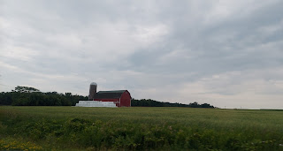

Lots of vineyards are in the Finger Lakes region of upstate New York.

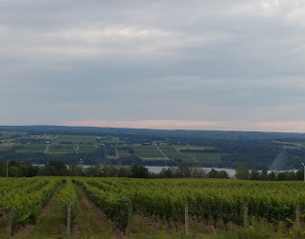

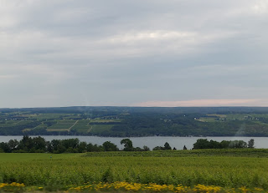

We arrived at Watkins Glen State Park at 9:00 a.m. for a SERIOUS hike. I had taken Amber here back in 2010 and have always wanted to return. It is seriously the most under-rated state park in the country as far as I'm concerned.

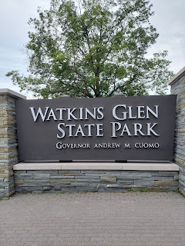

This is the start of the epic waterfall trail. Buckle up because there are 19 waterfalls in just 1.5 miles of a beautiful trail.

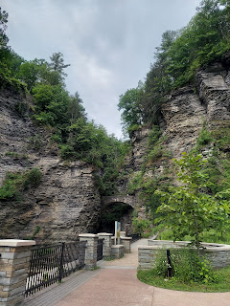

No need for much explanation on these next photos. Trust me.

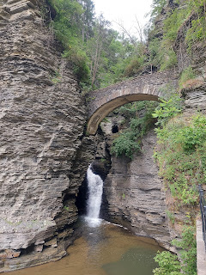

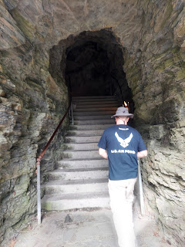

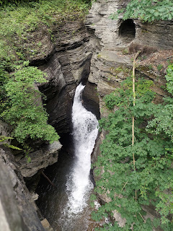

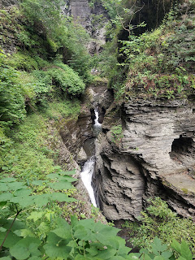

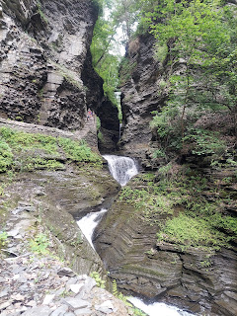

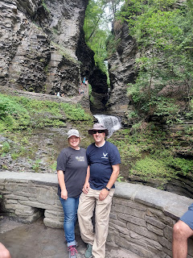

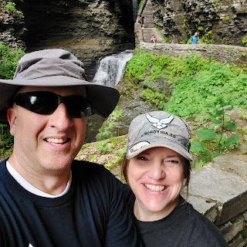

Heart-shaped cutout for the cascade to spill into . . .

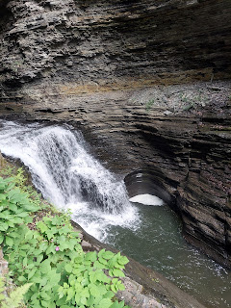

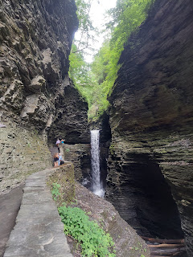

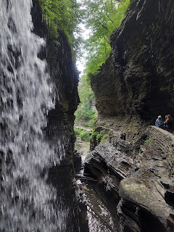

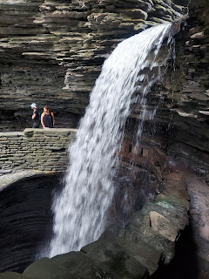

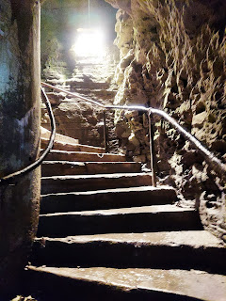

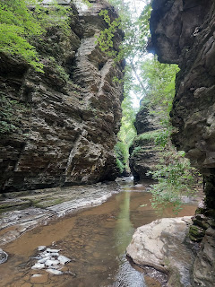

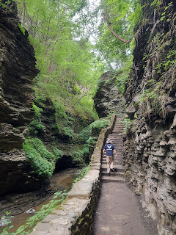

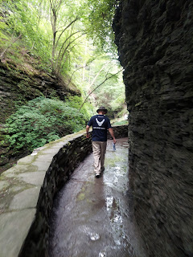

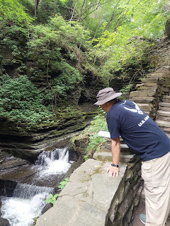

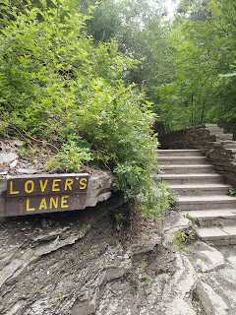

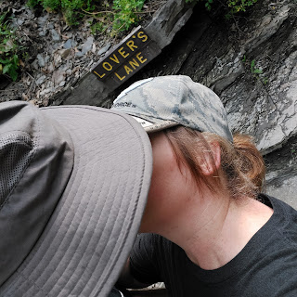

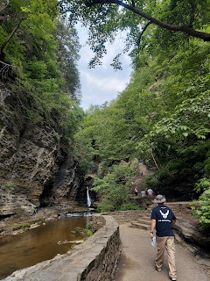

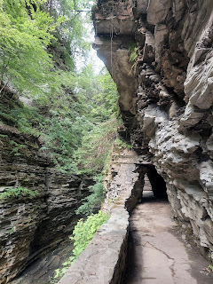

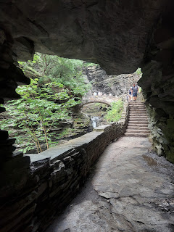

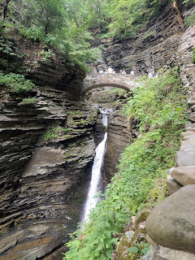

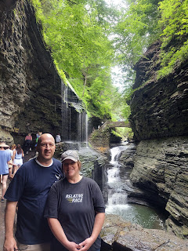

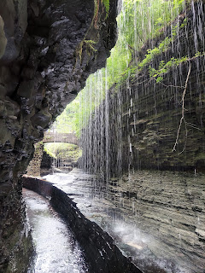

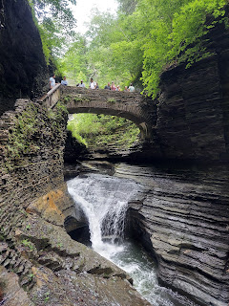

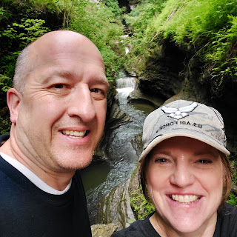

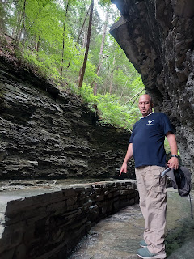

Some prehistoric man stepped in this very spot . . .

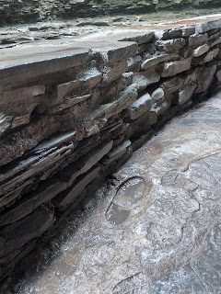

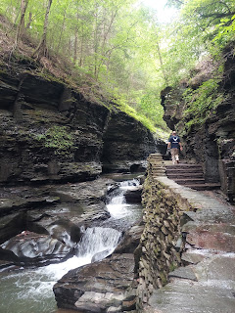

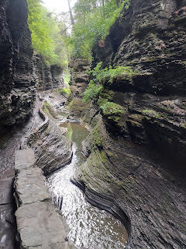

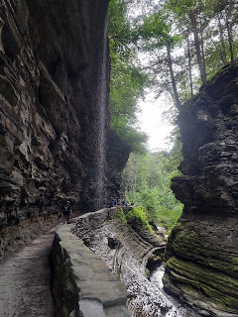

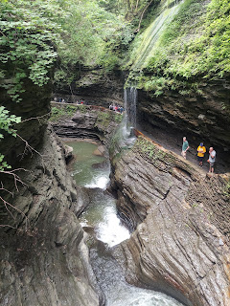

And we saw several Anabaptist families hiking together too. It sure was a lovely day to be out in nature with the fam. :) (sorry the photo is a little blurry)

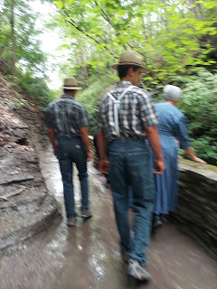

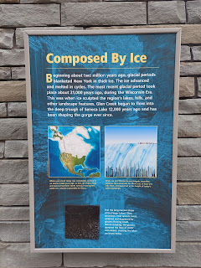

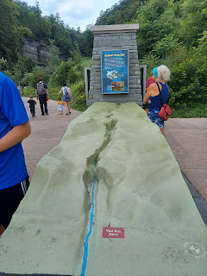

Here a few mind-blowing videos of the trails and waterfalls:

Video #1: (14 seconds)

https://photos.app.goo.gl/ywPWjcbEMipVLCK19

Video #2: (28 seconds)

https://photos.app.goo.gl/kr4ePZGRmgtvh2cFA

Video #3: (23 seconds)

https://photos.app.goo.gl/FrMmzjSDtGTteJsm9

Video #4: (3 seconds) I might be just a little obsessed with the Amish culture . . .

https://photos.app.goo.gl/odUTgfz7s1RkLgt29

By the time we left Watkins Glen State Park 90 minutes after we arrived, we were SO SWEATY!! I went into the bathroom to mop up a bit before we got in the car for a few more hours of driving. :)

Two hours later we arrived in Harmony, Pennsylvania to visit the LDS Priesthood Restoration Site along the Susquehanna River. For more information, click here:

https://history.churchofjesuschrist.org/subsection/historic-sites/pennsylvania/priesthood-restoration-site?lang=eng

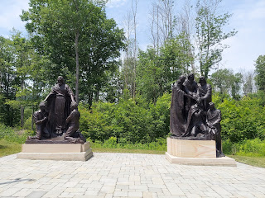

Inside the Visitor's Center we found several interesting things. I loved this map (because I love maps) - mainly because it helped show the location of Harmony, PA and where it was in proximity to Colesville, NY. Colesville was where Scott's ancestors, the Knight family, lived before moving west to Kirtland and later to Nauvoo. Sadly, we didn't have time to go up to Colesville that day.

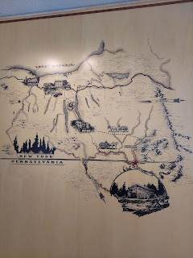

This shows what some of the ancient text looked like on the gold plates of scripture and what Joseph Smith and others had to interpret from.

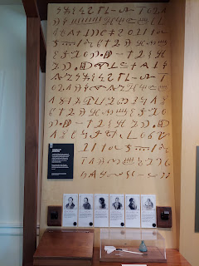

Emma Smith, wife of the prophet, was asked to create a book of hymns for the saints. With her family's Methodist background and her own upbringing, it's estimated that some 90 Methodist hymns were included in our first hymnbook.

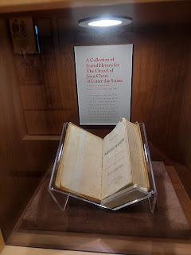

I love the artwork here, depicting Emma Smith and Joseph Smith.

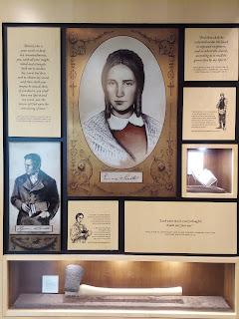

This is a re-creation of the Smith family home where Joseph and Emma lived for a time after they were married. Emma's family was nearby but she was practically disowned after she chose to marry Joseph and join the Church.

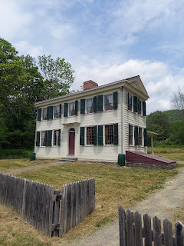

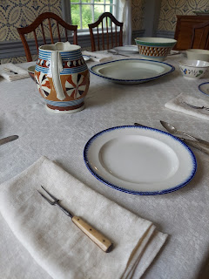

In talking with our tour guide as we walked from site to site, I learned that he lives in Cloverdale, CA and is in the same stake as my parents! His name is Elder Ed Bowen. He and his wife have been out in the Harmony, PA area for just 2 months so far, just getting started in their 18 month mission together. He even knows my Dad! What a small world.

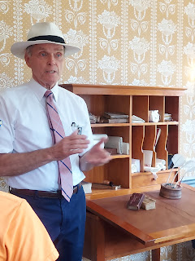

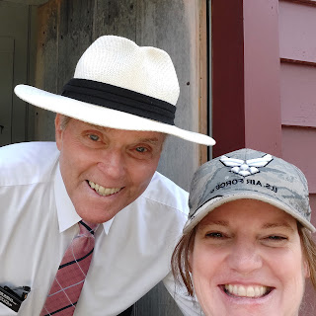

I really wanted to find Joseph and Emma's first baby's headstone in the adjacent cemetery, but A) it was ridiculously hot, and B) the cemetery was much larger than I thought it would be, and C) we needed to hurry on because we still had several more hours of driving to squeeze in to get to Lancaster, PA.

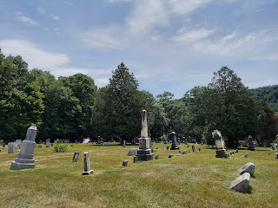

We did take some time to walk the beautiful path down to the Susquehanna River.

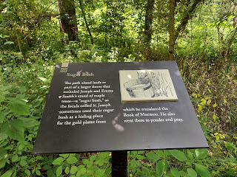

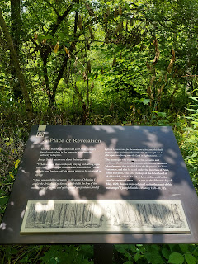

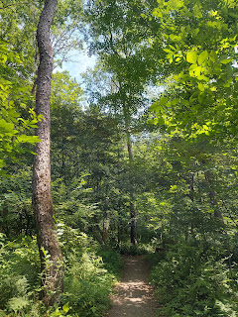

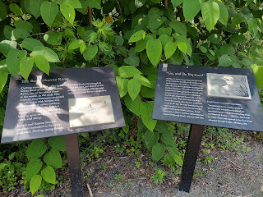

A short video as I rounded the bend and could see the river: (54 seconds)

https://photos.app.goo.gl/xMXyupC7FkN1s2XLA

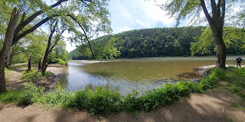

Scott, skipping a rock . . .

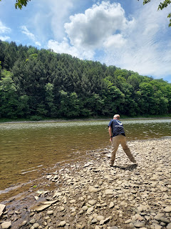

I really wanted to dip my toes in the river, but then I started noticing all the dead crawfish . . .



I found a different spot nearby, and took advantage of the "cleaner" water there.

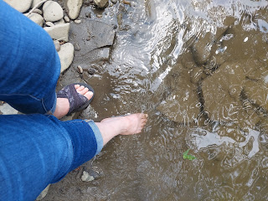

It was a beautiful river with forested areas on both sides, full of ferns and undergrowth. I could imagine the sacred experience that took place here all those years ago, and I was grateful once again for my membership in Christ's church.

While we drove another 3 hours south to the Lancaster area - and were in a hurry to get there in time to do a little shopping (mostly me of course) before things closed . . . cute happenings were happening in Washington DC.

Little Jack was on his Throne of Cuteness, holding his staff. I could almost hear him saying, "Could someone please fiddle for me?"

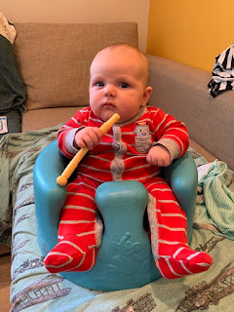

We arrived in the Lancaster area with barely 2 hours to shop and get dinner before everything closed. Talk about pressure!! This was our first stop: Bird-in-Hand Farmer's Market.

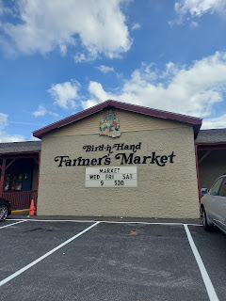

It was a massive building with absolutely everything the world over inside, everything Amish that is. Foods, clothing, trinkets, home decor, children's toys, puzzles, and a million more things I never had time to notice. I just had to hurry and get some stuff! No time for pictures either. But trust me, it was overwhelming. And amazing. Scott chose to just wait in the car for me. Which was fine, actually. Then I could just browse and choose. Rapid-style of course.

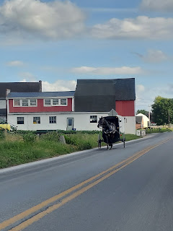

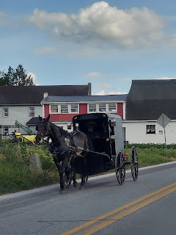

Everywhere we went in the 14 hours (total) we were there, we saw horses carrying Amish and Mennonite families from here to there down the main roads, right through the center of town.

Seeing a horse and buggy coming towards us: (14 seconds)

https://photos.app.goo.gl/XBKy9PQef73KHyB57

I was like a star-struck fan, trying to absorb the feelings I was experiencing left and right. After all, my own Mennonite ancestors immigrated here in the 1730's. I wanted to see, and capture with my camera, as much as I could before I had to leave. Things haven't changed a whole lot in the last 300 years. It all felt very authentic and beautiful to me.

I found an Amish fabric store to purchase a few pieces for my next quilt.

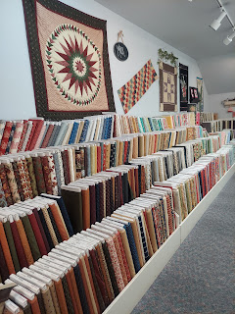

There are SO MANY stores all over everywhere, many of which sell Amish-made furniture, like these rocking chairs. Honestly, a person could spend days and days here and never see it all. I was very overwhelmed with how much there was to see and do, especially when we only had 2 hours to take it all in before everything closed on a Saturday evening. All the Amish shops are closed on Sundays, which is just as well, because in our faith, we don't believe in shopping on Sunday either. We choose to worship and make the Sabbath Day a holy day (and a day of rest) - as best as we can.

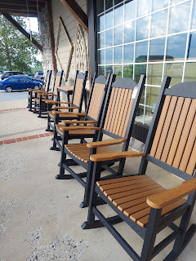

An Amish or Mennonite farm and field: (15 seconds)

https://photos.app.goo.gl/aMZqXxoSfMHwuhr99

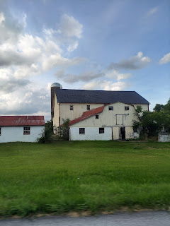

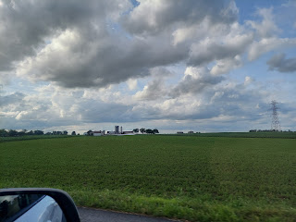

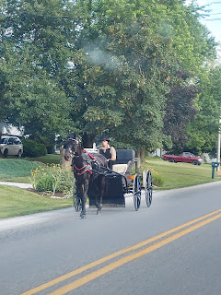

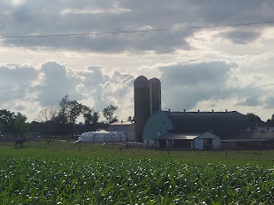

Three youth, traveling home together after a trip into town.

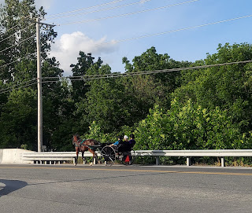

We ate at Gordon & Pam's favorite authentic Amish restaurant in Lancaster: Good 'N' Plenty.

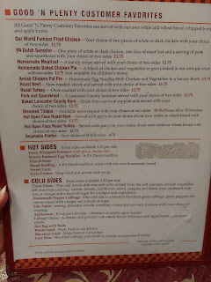

I ordered the PA Dutch Sampler, and chose the intriguing side dish "Chow Chow". It was delicious!!

The meatloaf was amazing, the pork and sauer kraut was very good, and the fried chicken just tasted like any other fried chicken. The bread was amazing, especially with the fresh apple butter on it.

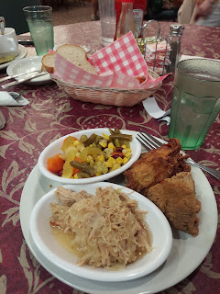

After our bellies were happy and full, we checked in at our AirBnb just down the street and got settled in for the night.

Sunday morning, as I was fixing my hair and makeup, I could hear the beautiful and melodious clip-clop, clip-clop, clip-clop of a horse and buggy outside. Many,

many

Amish and Mennonite families were on their way to church together early in the morning. What a beautiful sight it was.

Click here to watch a little family on their way to church: (10 seconds)

https://photos.app.goo.gl/qGhZZxJruceYrGqi9

Sunday:

We headed south once again, trying to make our way back to Harpers Ferry and all the Harmon family members there. Just 2.25 hours to go!

We passed through Gettysburg, PA on our way.

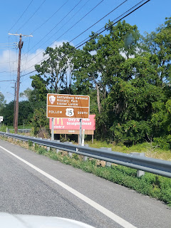

During church, I couldn't resist capturing this little guy, sleeping in his grandpa's arms. Jacob and Hannah had come out to Gordon and Pam's house to spend Saturday night so we could all be together for Sunday.

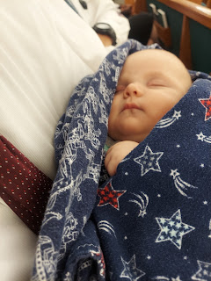

After church we had a short conversation with Benson before heading over to Scott's sister Sharon's house for a family BBQ.

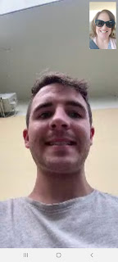

At Sharon's house in Charles Town, WV, Jack was the center of attention - no surprise there!

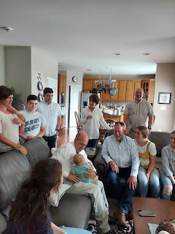

Standing from the left: Vanessa Jackson, Mason & Brendon Dever, Bev Vian, and Gordon Harmon.

Sitting from the left: Hannah, Scott holding Jack, Ken Vian, Hunter Jackson, and Sydney Dever.

Something was sure funny - something that Jack was doing - but we can't remember what it was. But I'm sure it was absolutely fantastic!

The standing group below now includes Jacob on the left, and Taylor Jackson hugging her mother, Vanessa.

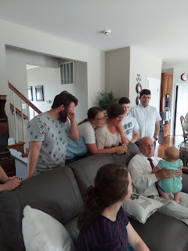

We had a second video chat with Benson so that he could say hi to everyone at Sharon's house. Those two are SO CUTE together!! I am SO looking forward to seeing them in a few weeks here in the U.S.

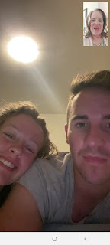

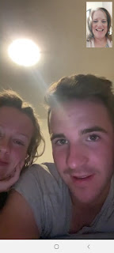

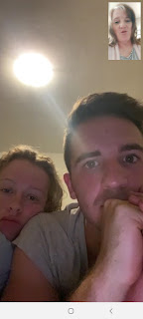

How do you like Benson's new hairstyle? I kinda like it!!

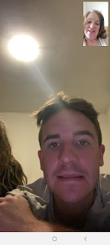

The girl cousins adored passing Jack around and giving him lots of love.

These are Scott's sister Bev's granddaughters: Taylor Jackson, Sydney Dever, and Hunter Jackson.

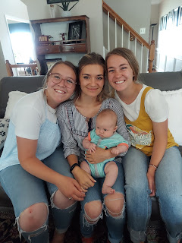

We celebrated Brendon Dever's birthday, too! I didn't even know it was his birthday until they said, "Okay, we're ready to sing to Brendon!" ha ha

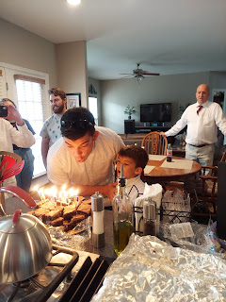

The last thing we did before dispersing was to take a big family photo. But this wasn't your ordinary family photo. Zoom in and look at everyone's teeth. Try not to pee your pants laughing!!

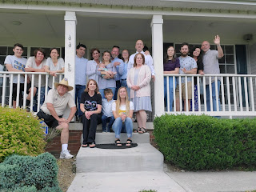

Standing in the back, from left to right: Mason Dever, Vanessa Jackson, Emily Dever, Brendon Dever, Bev Vian, Sydney Dever (holding Jack Harmon), Ken Vian, Taylor Jackson, Scott & Michele Harmon, Hannah & Jacob Harmon, Pam & Gordon Harmon

Sitting in the front, from left to right: Thom & Sharon Orf, Jackson Dever, and Hunter Jackson

Fun Fact: It was Sharon who had the idea of us wearing hillbilly teeth and posing for a family photo. She bought all the teeth and we chose which set we wanted to use. What a fun idea!! :)

Eventually we had to say goodbye to the newest love of our life: Jack.

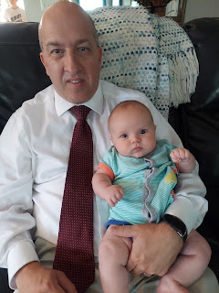

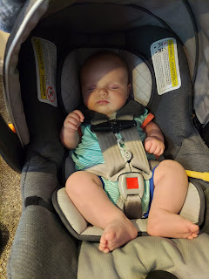

One final update:

Jacob and Hannah have decided to come back to Utah and Idaho for the next little while. They will leave their household belongings in Washington DC, but since Jacob will be working remotely for the next 6 months, he can basically be anywhere. They are trying to get someone to take over their lease on their current apartment, and once that happens they will line up a better place to live until his time in DC ends in two years. So in the meantime, they will stay a little while with Hannah's family down in Utah, and a little while with us up in Idaho.

They didn't know that he would be working remotely for a solid period of time until they got all the way across the country. But it's okay - we were happy to drive that U-Haul all the way to the east coast for them. They will have needed all of their stuff at some point, so it might as well have been during good summer weather!